**Programmers Paradise Technical Society**

**Nextronix**

## ****Arduino Programming Workshop – Event Report****

### ****Event Details****

### ****Date:**** May 5, 2025

### ****Day:**** Monday

### ****Mode:**** Online

### ****Venue:**** Virtual (Hosted via online conferencing platform)

### ****Event Highlights****

* Interactive hands-on session focused on Arduino programming for beginners
* Live demonstration of a basic hardware project (blinking an LED)
* Introduction to Arduino boards, software setup, and essential coding functions
* Real-time Q&A with the presenter
* Easy-to-follow guidance from industry expert Mr. Aman Sonwani

### ****Aim****

The primary aim of the workshop was to introduce participants to the basics of **Arduino programming** and embedded systems, with a practical approach to building circuits and writing code. The session aimed to empower attendees to begin their journey into electronics, coding, and technology innovation.

### ****Involvement and Attendance****

The workshop saw active participation from students, tech enthusiasts, and beginners interested in electronics and automation. The session was conducted by **Mr. Aman Sonwani**, who guided all attendees through setup, programming, and project execution.

### ****Key Topics Covered****

* Overview of Arduino and its applications in modern technology
* Introduction to different boards like **Arduino Uno**, **Mega**, and **ESP32**
* Downloading and installing the **Arduino IDE**
* Understanding the structure of an Arduino sketch (setup() and loop()
* Live demo: **Blinking an LED** using Arduino, breadboard, and jumper wires
* Explanation of key functions: pinMode(), digitalWrite(), and delay()
* Applications of Arduino in **IoT**, **automation systems**, **prototyping**, and **interactive technology**

### ****Conclusion****

The Arduino Programming Workshop provided a solid foundation for participants to explore **embedded systems and microcontroller-based development**. Through practical demonstrations and clear guidance, Mr. Aman Sonwani successfully conveyed the potential of Arduino in various tech fields. The session inspired attendees to continue learning and experimenting with hardware programming and real-world applications.

**Insights Of Workshop:**

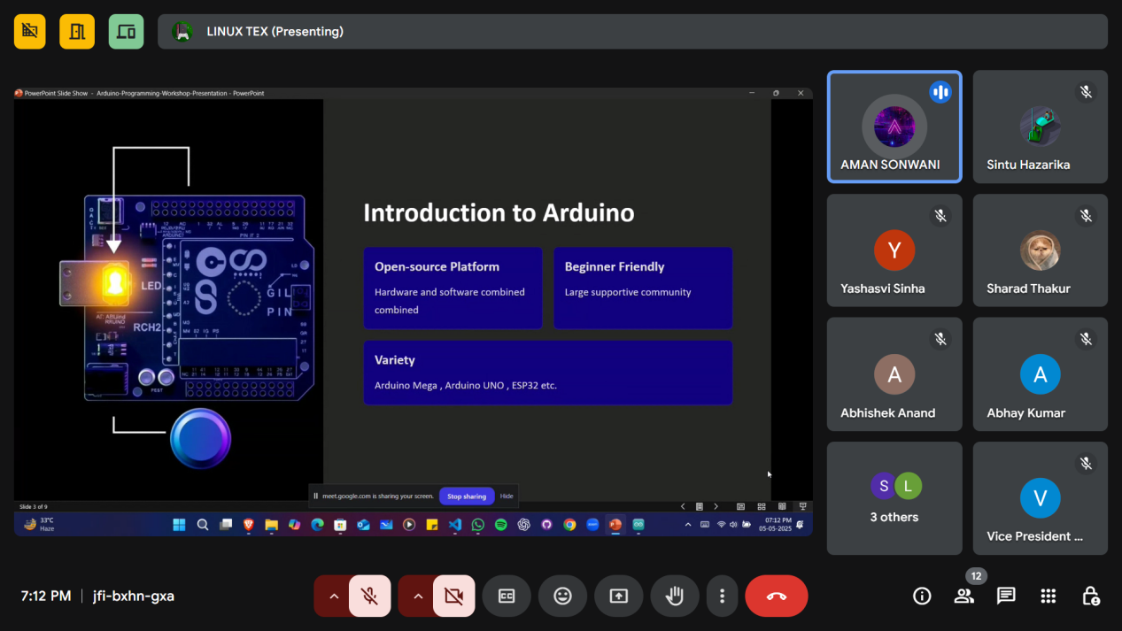

**Attendance:**

